Analysis

**ANALYSIS**

**Background to and identification of the problem:**

**Client:**

* Mrs Clark (Head of maths department)

St Francis Xavier is a college in Balham, South London with over 1500 students and 200 teachers, offering a variety of A-Level, BTEC and GCSE courses.

The Maths department currently has a total of 400 Students and 7 Teachers. From that 400, 150 are A Level Maths students and over 250 GCSE Maths students. The teachers in the maths department need a system to assist in students’ learning and to track students’ academic progress. Additionally, the students need an interactive system where they can learn GCSE maths outside of lesson hours.

The maths department uses an interactive PowerPoint pack to teach GCSE maths. I have proposed a solution/software called “MyGCSE Maths”, a virtual learning environment that provides a better user experience than the previous learning method (PowerPoint pack) deployed by the maths department.

**Description of the Current System:**

Currently the GCSE Maths teachers use a PowerPoint resource pack to aid in teaching. Typically the teacher would choose a PowerPoint file from the huge PowerPoint resource pack, run the presentation, click on the topic they want (e.g. Numbers, algebra), then select a question.

The teacher would display the questions on the white board and students would raise their hand in order to get picked by the teacher to answer a question. If picked, the student would approach the white board and use the whiteboard pen to select the answer to the question presented.

After a student has answered a question, the PowerPoint presentation displays the correct answer so the student can compare it with their answer. If wrong, the student has the option to be shown how to arrive at the correct answer. Finally, if the student still doesn’t understand the teacher could then explain it to them further.

**The problem(s) with the current system:**

* The teacher has a huge list of PowerPoint presentations to select from, which can become very confusing when the teacher is selecting a set of questions. This is because the current system is unorganized as the questions are in different PowerPoint presentations as opposed to the questions being available from one central location.
* If the teacher wanted to find a specific question and didn’t know which PowerPoint file contained the question, they would have to look through the entire PowerPoint resource pack, which can be very frustrating and tedious.
* Only one students can answer the question that is on the white board at a given time. Therefore it’s not possible for all the students in the class to be engaged with learning at the same time, so the learning pace for the whole class may not be as fast as it could be.
* The teacher is not able to accurately monitor the progress of students over a period of time since there isn’t a system which they use to monitor their progress; this is because the activity is not one you would usually keep track of. The only alternative is to remember student’s progress, which can often be inaccurate.
* The current system is not suitable for students who may be shy or have anxiety when around others. They’re not likely to raise their hand in order to answer questions, therefore not benefit from the Interactive learning experience.

**Identification of prospective users**

**End Users:**

* GCSE Maths Students & Teachers

There are three types of users to the system (admin, teacher and student) and before a user can access the system they must first login.

*Admin:*

The admin is responsible for managing the system. They can create new user accounts and new classes which they can assign teachers to. They can also assign students to an existing class, this means that teachers can only view the students that have been assigned to their class.

*Teacher*

The teacher is responsible for managing the learning of the students. The teacher would be able to search for students in their class and view the progress of the all the homework they have completed. The teacher can also add, edit and delete questions from the system.

The teacher is also responsible for creating new quizzes/homework which students can login to the system to complete. Upon completion of a quiz/homework, the teacher can see the students result and an overview of the students’ performance for all the quizzes/homework they have completed.

*Student*

Student logs in to the system, and after completing a quiz they would be provided with feedback on their performance. They can also see which quizzes they had previously had completed and see new quizzes when the teacher sets them.

Identification of user needs and acceptable limitations

**What they want the new system to do – User needs:**

Mrs Clark wants the following end users and the system to be able to do the following.

General system requirements:

* To store a lot of GCSE Maths questions for students to attempt.
* System should be easy to use and enable students to learn topics easily
* Each user to have a unique account they use to access the system.
* To distinguish users by rank. For example, admin, teacher and student rank.
* A feature that would generate complex maths questions of specific topics (e.g. shapes, algebra and numbers) and store it in the system for students to answer and for teachers to manipulate. This includes generating questions with images
* A feature to automatically generate the username and email for each user added to the system in accordance to their college user credentials.
* Able to mark a students’ answer and tell them if they got it right or wrong.
* Able to mark quizzes taken by students and return the results to their teachers.

Admin

* Able to Create “MyGCSE Maths” credentials for different users types (e.g. admin, teacher and student), in order for them to access the system.
* Able to add, update and delete user credentials.
* Able to add new classes and assign students and teachers to a class.

Teacher

* Able to manually insert questions into a database, including questions with images.
* Able to use the question generator features to generate different types of question. For example, generating multiple or non-multiple choice questions of different topics like numbers, shapes and algebra.
* Able to search for questions by a search criteria. For example search for questions by topic, or by grade difficulty levels
* Able to search for students by their name
* Set quizzes/homework for students to complete.
* Able to see the students’ performance for each completed quiz
* Able to see students’ performance by topic
* Able to the whole classes performance by topic
* Export questions and answers (mark scheme) of all existing questions/quizzes in the system to the teachers’ computer.

Student

* To complete quizzes that have been prepared by their teacher.
* Get feedback on each set of questions or quizzes they have completed.

User Limitations:

* The proposed solution will not be web based due to the amount of time it will take to learn a web scripting language, this means that there won’t be a website which users visit in order to access the system and therefore the final system has to be in the form of an executable.
* In addition, the proposed system can only be used within the college network for it to function properly.
* The question generator feature will not be able to generate questions for all GCSE maths topics and sub topics due to time constraints. However, the question generator feature will be able to generate a variety of questions for the core topics like algebra, shapes, numbers and handling data.

**The skill levels of people using the new system**

The Admin would require basic computer skills. They need to be able to add, update and delete user accounts and classes in the system.

The teacher would require basic ICT skills, e.g. using Keyboard, mouse. This is so they can use the feature that generates questions and view progress of student.

The student would also need basic ICT skills and maths skills in order to use the system to answer the questions provided by their teachers.

**Data Source(s) and Destination(s):**

Current System

|  |  |  |
| --- | --- | --- |
| **What Is It** | **Source** | **Destination** |
| Maths Questions | PowerPoint resource pack | Whiteboard |
| Answers to questions | PowerPoint resource pack | White board |

New System

|  |  |  |
| --- | --- | --- |
| **What Is It** | **Source** | **Destination** |
| MyGCSE Maths account details | Created by admins in the admin panel | User SQL Table |
| User Information | Created by admins in the admin panel | User SQL Table |
| Questions | Created by teachers in the teacher panel | Question SQL Table |
| Question Answers | The answers students enter during their quiz | Answers SQL Table |
| Quizzes | Added by the teacher which consists of the existing questions in the database. | Quiz SQL Table |

**The frequency with which the users access the program**

The admin would access the program once in a while. They will mainly use it for creating new user logins and new classes, which is normally done at the beginning of the academic year.

In addition, there is a college rule where if the student is more than 10 minutes late to their lesson, they’re not allowed to come in for that period. So the teacher sends them to the school library (LRC) to get on with some work. In this case, the teacher can set the student work to do on the MyGCSE Maths system in the school library.

**Data Dictionary**

**Current System:**

|  |  |  |
| --- | --- | --- |
| **PowerPoint File** |  |  |
| **Data** | **Data Type** | **Description** |
| Questions | PowerPoint with text and images | These are the questions that are picked from the PowerPoint file. This is what the student would answer. |
| Answer to questions | PowerPoint with text and images | This is the answer to the current question on the PowerPoint file. |

Note: My Data Dictionary and Data Volumes for my proposed system can be found in the design section.

**Data Flow Diagram**

Current System

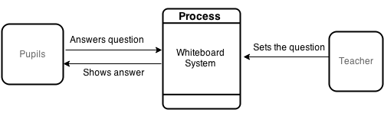Level 0 Diagram:

Level 1 Diagram:

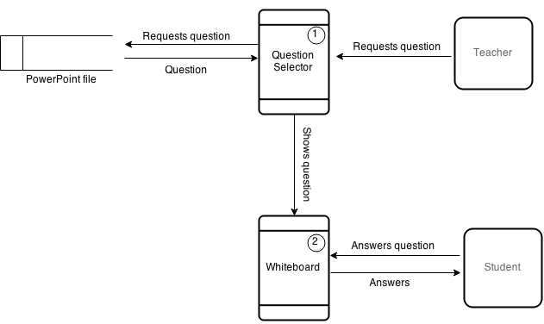

Proposed System

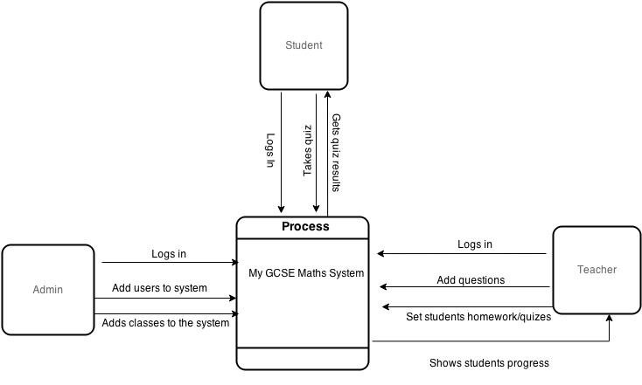Level 0 Diagram:

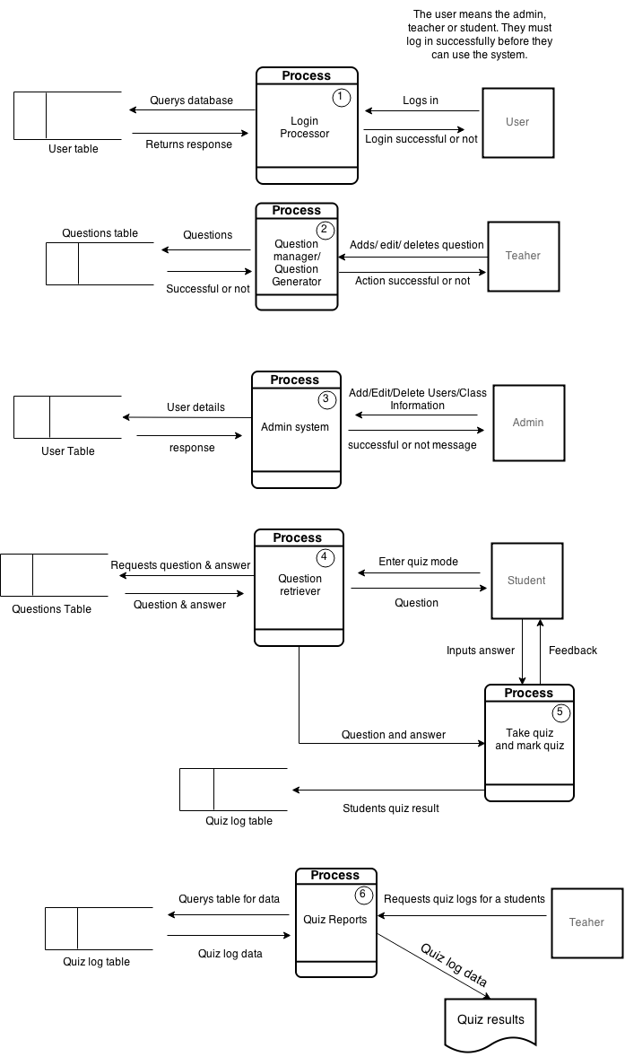Level 1 Diagram:

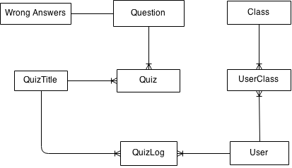Entity-Relationship Diagram

This table only holds 3 false answers for a multiple choice question. The actual answer to the question is stored in the Question table.

I inserted the table UserClass in-between User and Class remove the many to many relationship. I also inserted the table QuizLog in-between User and QuizTitle to remove the many to many relationship. Also, each question can appear in many quizzes and for each question, there can be one false answer record which contains multiple false answers.

Object orientation planning

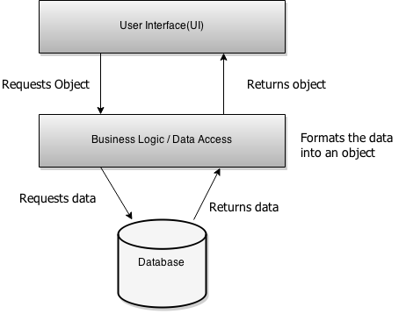I will design my system around the structure of the 3 Tier application model.

The idea behind my class setup is that there are methods in the business logic layer which assists in completing tasks in the UI layer. For example, in the UI layer I plan to have a UI Form for generating questions, in the business logic layer, I plan to have a QuestionGenerator class. When called, the class will generate questions, add them to the database and return a response.

I will build my system around the 3 Tier application model because it follows a structured approach that allows everything to be modularised. This means the methods in the business logic layer is easy to use and the UI layer is never accessing the database directly. Instead it uses a stored procedure that accesses, formats and returns the data.

|  |
| --- |
| **Class Name:** EntityBase  **Description:**  The entity base class is where all the service classes will inherit from and it’s also where all the shared custom objects and methods will be declared. Therefore every derived class can make a reference to the objects and methods in the base class in order to use them.  **Example methods:**  Public Object SQLCmd  Public Object SQLCon  Public String SQLConString  Public Sub: OpenConnection()  Public Sub: CloseConnection() |

|  |
| --- |
| **Class Name:** LoginService  **Description:**  This class will handle login requests to the system. For example, there will be a method to check if the username and password entered at the login page. If it is valid it will allow the user to access the system.  **Example methods:**  Public Function: IsValidLogin()  Private Function: GetUserData() |

|  |
| --- |
| **Class Name:** AdminService  **Description:**  The admin service class is mainly used for managing user accounts in the system. It’s used to add, delete, and update user accounts in the database.  **Example methods:**  Public Function: AddAccount()  Public Function: DeleteAccount()  Public Functuion: GetUsers()  Private Function: GenerateUsername()  Private Function: GeneratePassword()  Private Function: GenerateEmail() |

|  |
| --- |
| **Class Name:** TeacherService  **Description:**  This class is used to perform teacher specific tasks. For example, CreateQuiz, GetUserResults and GetStudents  **Example methods:**  Public Sub: Logout()  Public Function: GetUncompleteQuizzes()  Public Sub: SaveQuizResults() |

|  |
| --- |
| **Class Name:** StudentService  **Description:**  The student service class is for performing student specific tasks. For example, there is a method for getting all the quizzes the student hasn’t completed.  **Example methods:**  Public Sub: Logout()  Public Function: GetUncompleteQuizzes()  Public Sub: SaveQuizResults() |

|  |
| --- |
| **Class Name:** QuestionHelper  **Description:**  This class will be used to manage questions. It is called when you need to add, edit, delete or to request a question that is in the database.  **Example methods:**  Public Function: AddQuestion()  Public Function: EditQuestion()  Public Function: DeleteQuestion()  Public Function GetQuestion()  Private Function GetFalseAnswers() |

|  |
| --- |
| **Class Name:** QuestionGenerator  **Description:** This class is used for generating questions. It has 4 nested classes which all generate a specific type of question. When the GenerateQuestion() method is called, it will call one of the nested class to generate a question(depending on the requested topic to be generated) and a list of generated questions is then returned to the caller.  **Example methods:**  Public Function: GenerateQuestion()  Private Class: AlgebraQuestion  Private Class: ShapesQuestion  Private Class: NumbersQuestion  Private Class: HandlingDataQuestions |

The diagram below illustrates the hierarchy structure of the QuestionGenerator class.

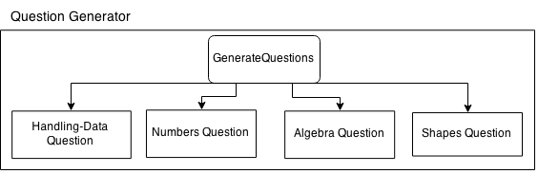

Inheritance

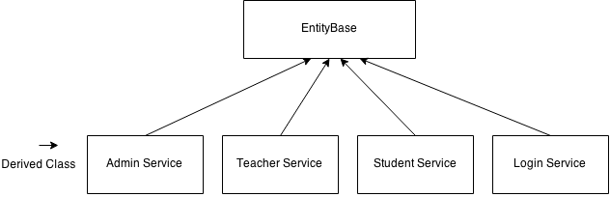The diagram below is an example of how and where I am planning to implement inheritance in my proposed solution. All the Custom objects and objects required to connect to the database will be defined in the base class, and by inheriting all sub classes can use the predefined objects.

Polymorphism

In the BaseClass I will have a method called PromptLogout() which is called to logout a user from the system. It will prompt the user with a message saying “Are you sure you want to logout?” and if they agree it will log them out. I will override this in the Student Service class, so the message will say “Are you sure you want to logout? Any unfinished progress will be lost”. The student could be in the process of completing a quiz when they decide to logout and this will let them know that their progress is not saved if they haven’t finished.

Objectives

**General system objectives:**

* To allow record user input, process it and add to database if it meets certain requirements. For example, the length of data entered must be greater than 0 before it can be added to the system.
* To only allow authorised users to have access to the system. Once logged in, the system will provide the user with the interface corresponding to their rank. For example, teachers will see the teacher form and students will see the student form.
* To retrieve students quiz results data from the database, process it (e.g. calculate the average score) and present it to the teacher accordingly. For example, the system will retrieve a student’s raw quiz result, then calculate the percentage before showing the students’ performance to the teacher.
* To save the image of a question and store it in the database. The system should also be able to retrieve the image from the database and display it to the user.
* Allow teachers to be able to print/export mark schemes of the questions in the database.
* System should be able to generate appropriate mathematical shapes for geometric shapes.

**Specific system objectives:**

* When a student answers a question, the system should be able to accurately mark their answer to the question.
* The system should be able to catch errors and provide an appropriate error message instead of crashing. For example, if the system failed to establish a connection to the database, instead of freezing and crashing, it will present a message box informing the user that a connection to the database could not be established.
* The system would be able to generate questions depending on a criteria set by the teacher. For example, if the topic selected is “Algebra”, difficulty level selected was “B” and amount requested was 24, then the system would generate 24 algebra questions of grade difficulty B and insert them into the database automatically. The questions now exist on the system, therefore they can be accessed by students and teachers.
* The system should be able to generate shape type questions by drawing the shape, labelling each side of the shape and the store the image on the database.
* The system should be able to automatically generate the username and email for each end user added to the system based on their first name, last name and User ID.
* Teachers should be able to track students’ progress and see their performance on a line graph over a period of time.
* The system should allow the teacher to set students quizzes and the system would recognise when a student has completed a quiz or not.
* The system will be able to let the teacher export an overview summary of the quizzes completed by all the students in their class. The system will fetch all the quizzes each student had completed, calculate the total average for each, and then sort each student based on their total average in an ascending order. The data would be exported to a .txt file.

### Potential Solutions

|  |  |  |
| --- | --- | --- |
| Suggested Solution | Pros | Cons |
| Web Based Application – HTML,CSS,PHP, phpMyAdmin | + Students would be able to use the system anywhere provided they have Internet connection and know the URL of the website. Therefore, this solution is more accessible for users.  + It has no machine dependencies, it can be run on any machine that has a web browser, which all modern computers have.  + Database contents can be accessed anywhere since it’s hosted on a remote database. | - If the user doesn’t have internet access they will not be able to access the website.  - Requires a server to host the website on, which can be costly and may be unreliable due to server downtime.  - The college would have to spend money to hire a programmer to develop the software, which can be very costly.  - This solution would be tailor made for SFX Sixth Form College, therefore is a bespoke software. The disadvantages to bespoke software is that there won’t be many users, so it’s likely that the program could contain a lot of unreported bugs. |
| VB.NET application and MSSQL based solution | + VB.NET is a powerful high level language that has many inbuilt libraries, so I could use them to my advantage in creating solutions to complex problems. For example I could use the graphics classes in VB.NET to implement the question generator algorithm that will generate shape type questions.  + VB.NET allows for quick development, with the built in tools like Toolbox enables me to design the UI of my application easily with little effort. Also VB.NET is well Documentation by Microsoft (MSDN), so I could easily search and learn anything I didn’t previously know and implement it.  + Using MSSQL enables me to produce complex table structures, and perform complex queries to extract the data.  + The system can be accessible even if the Internet is offline provided the user is still connected to the intranet network of the college. | - At the moment clients would not be able to access the program at home since the database is located on a local network on my school server.  - VB.NET has framework dependencies as well as OS dependencies. The program can only run on Windows operating system and Windows is the only OS that is capable of running the .NET framework. Therefore clients must have Windows and Installed the latest version of the .NET framework for the software to work. |
| MyMaths – My maths is a revision website that enables students to revise online using the resources they have available.  http://www.mymaths.co.uk/ | + Students would be able to access the program online anywhere in the world, provided they have internet connection and a web browser.  + It’s a well-established special purpose application with a lot of schools using it, so it’s likely to be good and effective for learning. It being well established means it is likely that the website works well with few bugs. | - The software is not a bespoke application, so it might not always meet the specific needs of the end users. For instance the teachers might want students to be tested in a different manner like a timed quiz. But they can’t because MyMaths doesn’t have that feature.  - The college pay a lot of money for the subscriptions fees. |

### Chosen Solution

### My choice is the VB.NET & MSSQL solution.

### I have chosen this solution because of what VB.NET & Microsoft SQL Server has to offer.

### VB.NET provides all the tools required to develop the system for my client and also has a large active community where I can get sufficient technical support to ensure the successful development of the system.

### Microsoft offers great documentation for VB.NET, therefore I would always have access to well explained & content rich information of the standard libraries of VB.NET and how to use them. This is good because it allows for quick development, and allows me to make use of the standard libraries available in VB.NET to develop my program. Therefore such libraries like the graphics library would allow me to use its tools to draw images at runtime. This would be useful as it means I can implement the part of my question generator that can generate shape questions at runtime.

### Using Microsoft SQL Server (MSSQL) as a method of data storage provides a more manageable and natural way to store complex data structures, making it easy to manipulate the data. For example, I could store data about students in the system, link each students to a class, and link each completed quiz to a student. Using SQL I could easily extract the data from the table in an efficient manner.

### In addition, a great advantage to using MSSQL is that I could link my VB.NET application with a MSSQL database, I can store data from my VB.NET application to my database, read the data, process it and manipulate it. This means interactions from my system can reflect on the database. Therefore teachers can then use it to add new questions, see all the students in their class etc.

### In contrast to the MyMaths solution, my chosen solution would be developed by me as part of my A2 Project, so it’s a cheaper solution for the college as they wouldn’t be paying subscription fees to MyMaths to use their services.

### In comparison to the web based solution, using my chosen solution (VB.NET & MSSQL) means that if the end users Internet goes down, they would still be able to use the software provided they are connected to the college Intranet and the Intranet is online. Whereas with the web based solution, if the end users’ Internet connection is offline, they would not be able to gain access to the system.

### Finally, in regards to the operating system & .NET framework dependencies of the VB.NET & MSSQL solution, the end users will be using the system mainly in college, and the majority of the college computers operate on windows OS and have the latest .NET framework installed. Therefore, the framework dependencies will not be a problem.

**Use of Formal Methods**

1st Meeting – This is the first meeting I had with Mrs Clark, I asked her some general questions so I could get a rough understanding of the current system and how to approach development of the new proposed system.

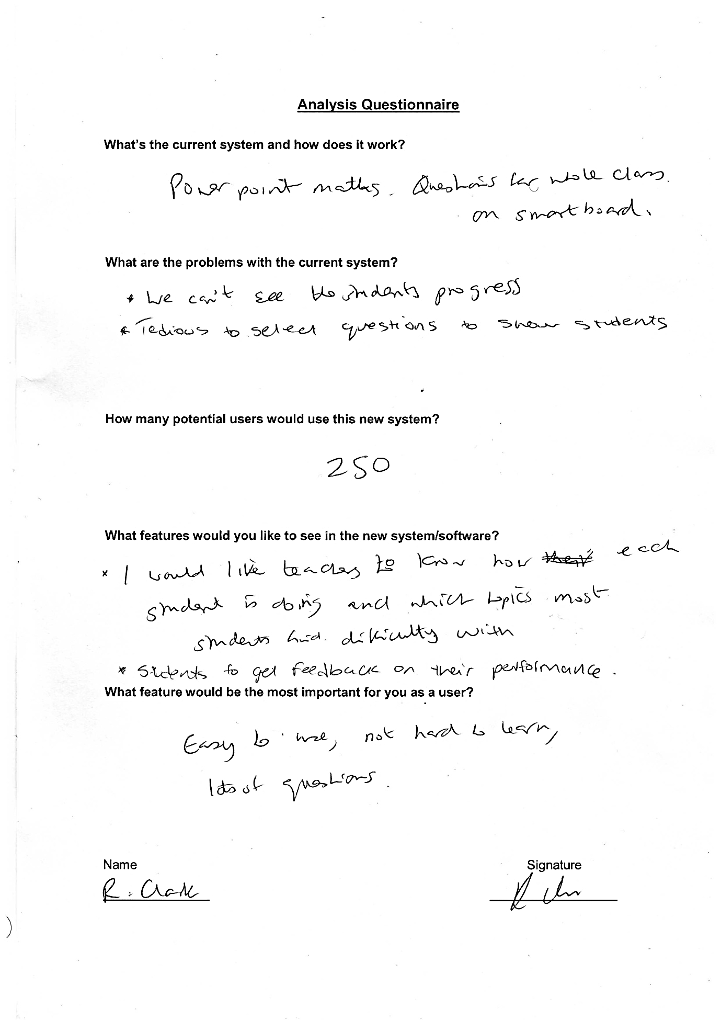

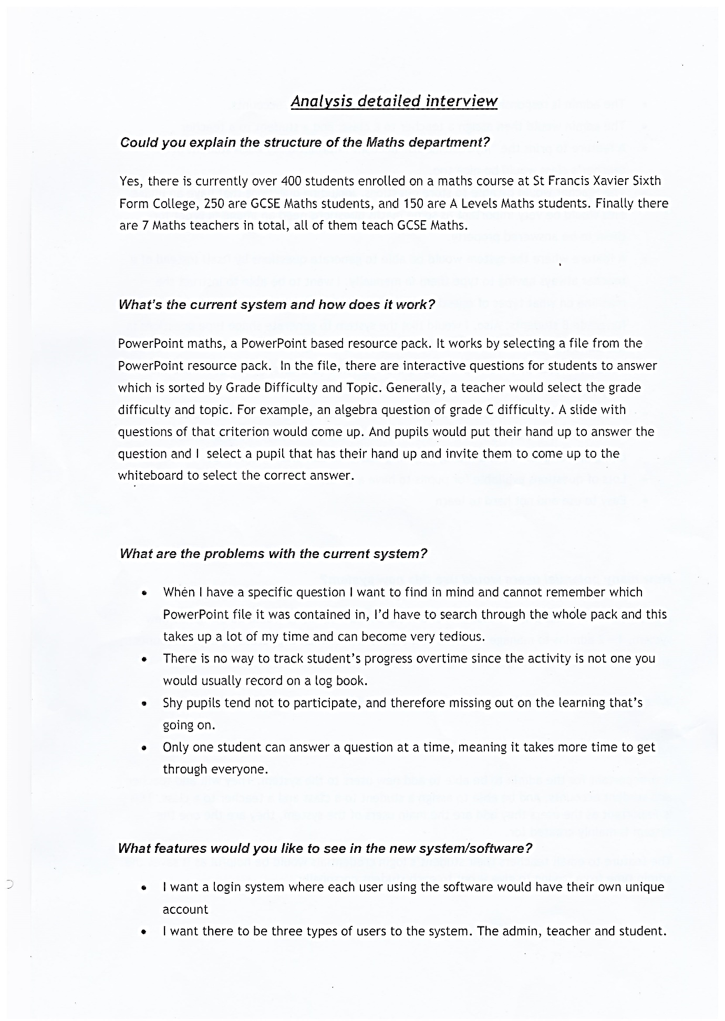2nd Meeting – I arranged to speak with Mrs Clark in further detail of the new system and the old system. She answered my questions in more detail, I then made notes and typed out the Interview. After I showed it to her, she then approved of it with her signature.

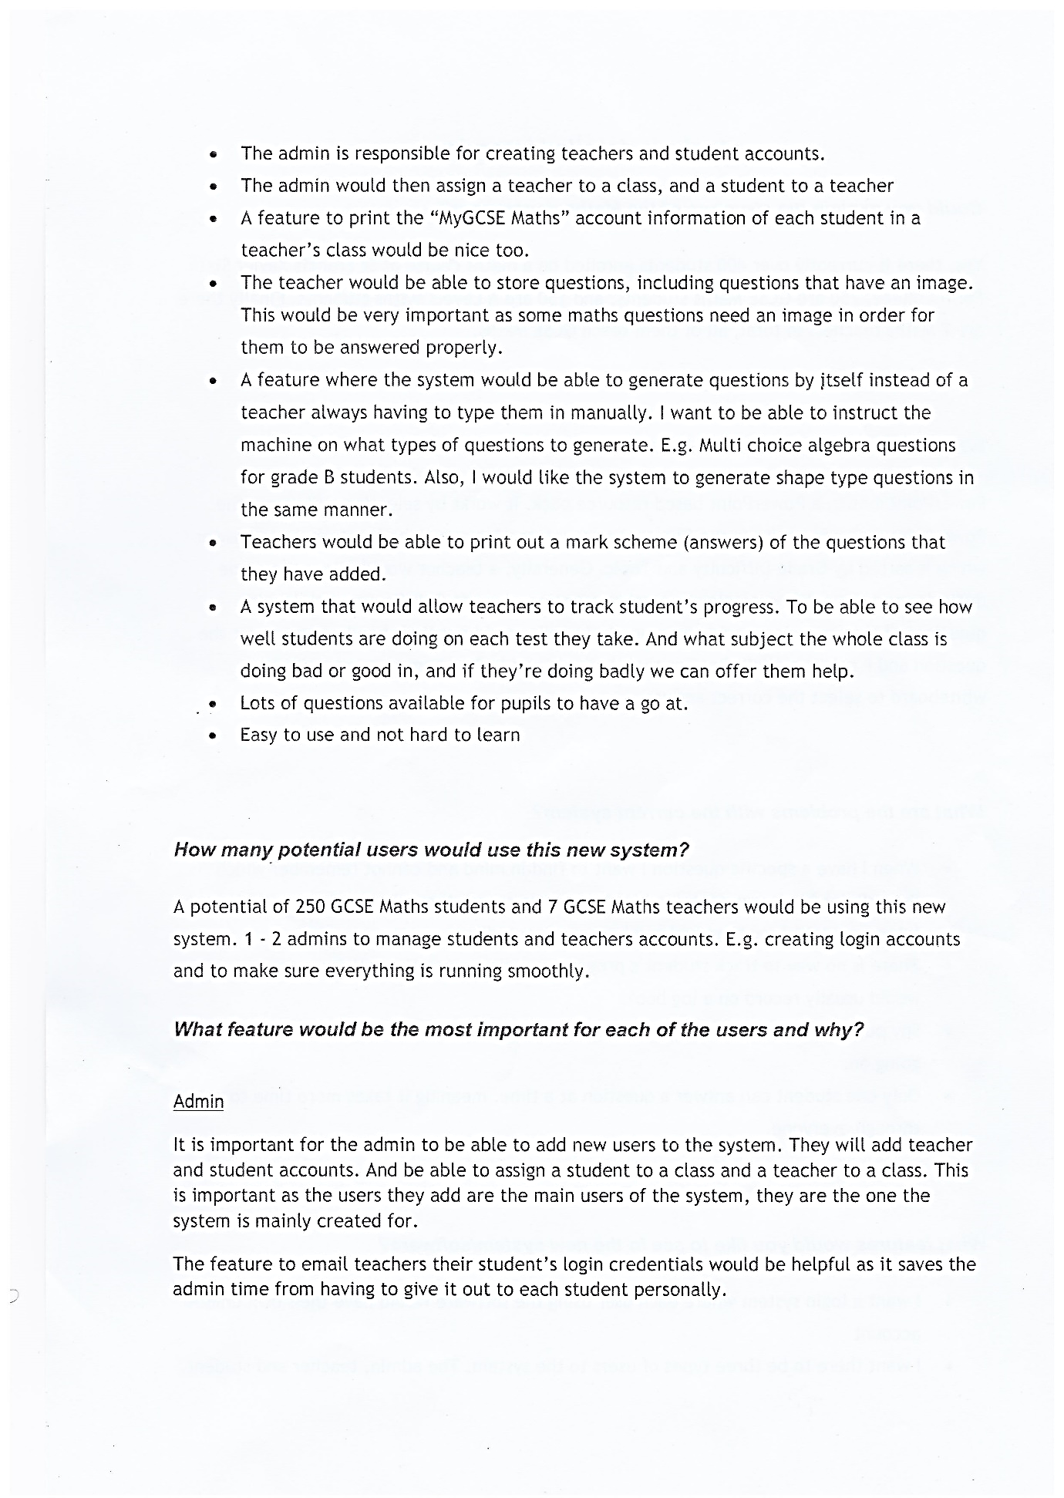

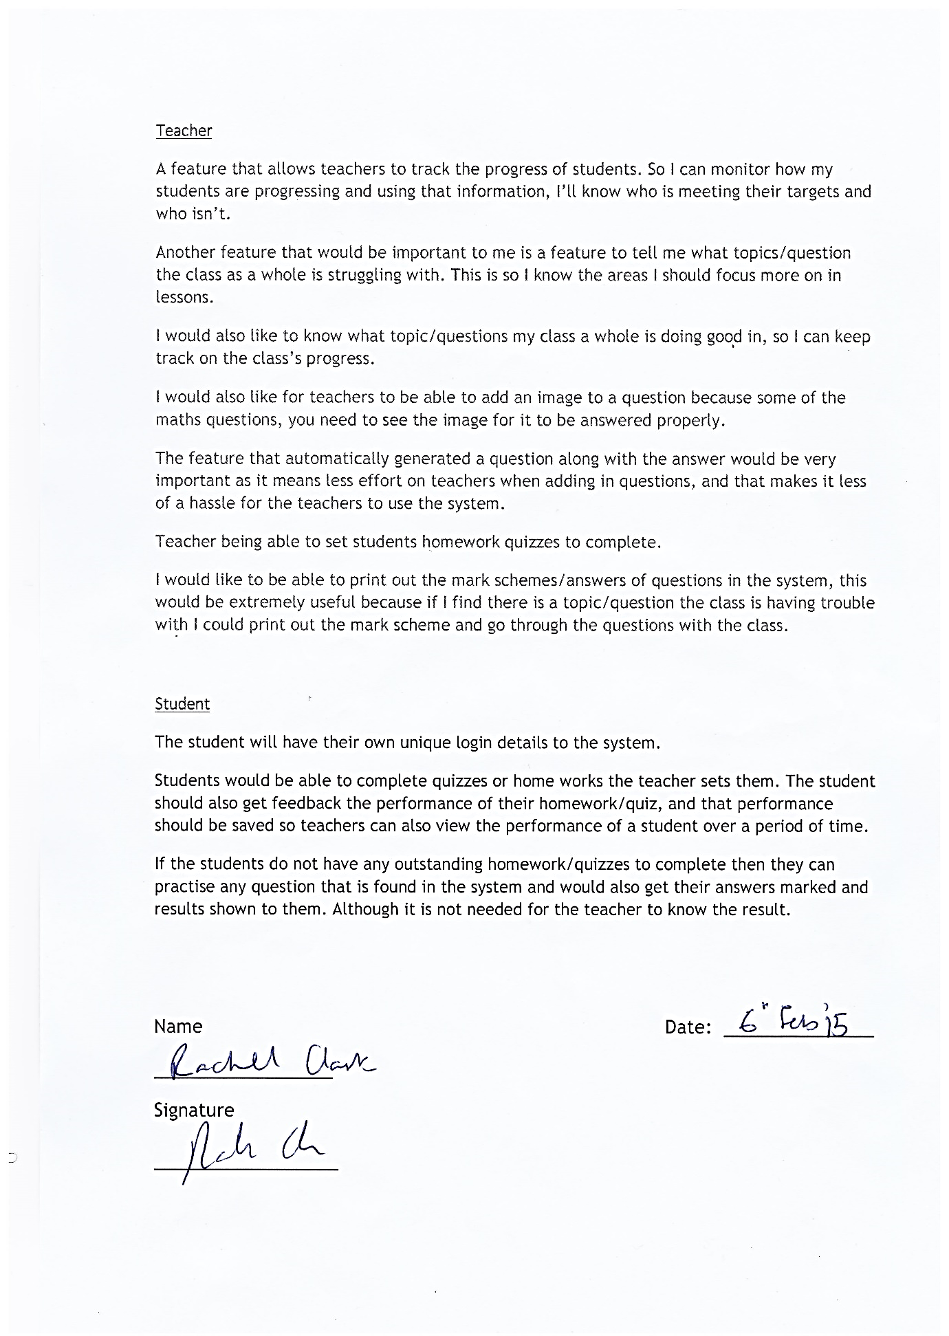

**Research Methods** - Observation of the current system

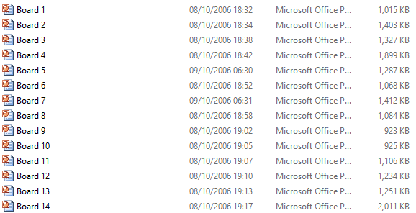

Teaches would select a PowerPoint file, which contains the questions & answers. As you can see it can be very tiring to have to go through all the PowerPoint files if you just wanted to find a specific topic/question and didn’t know where it was located.

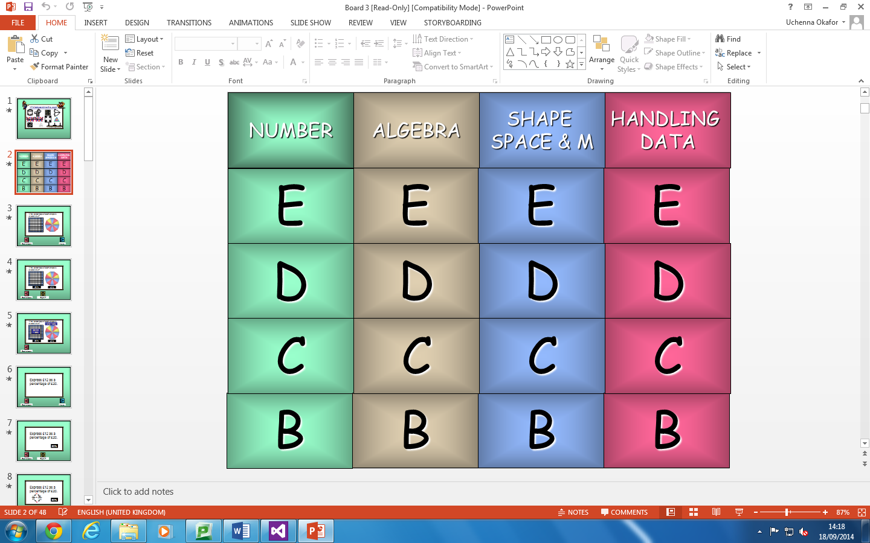

Teacher chooses the topic and grade difficulty level for the questions from the PowerPoint. Then the question will then be loaded up.

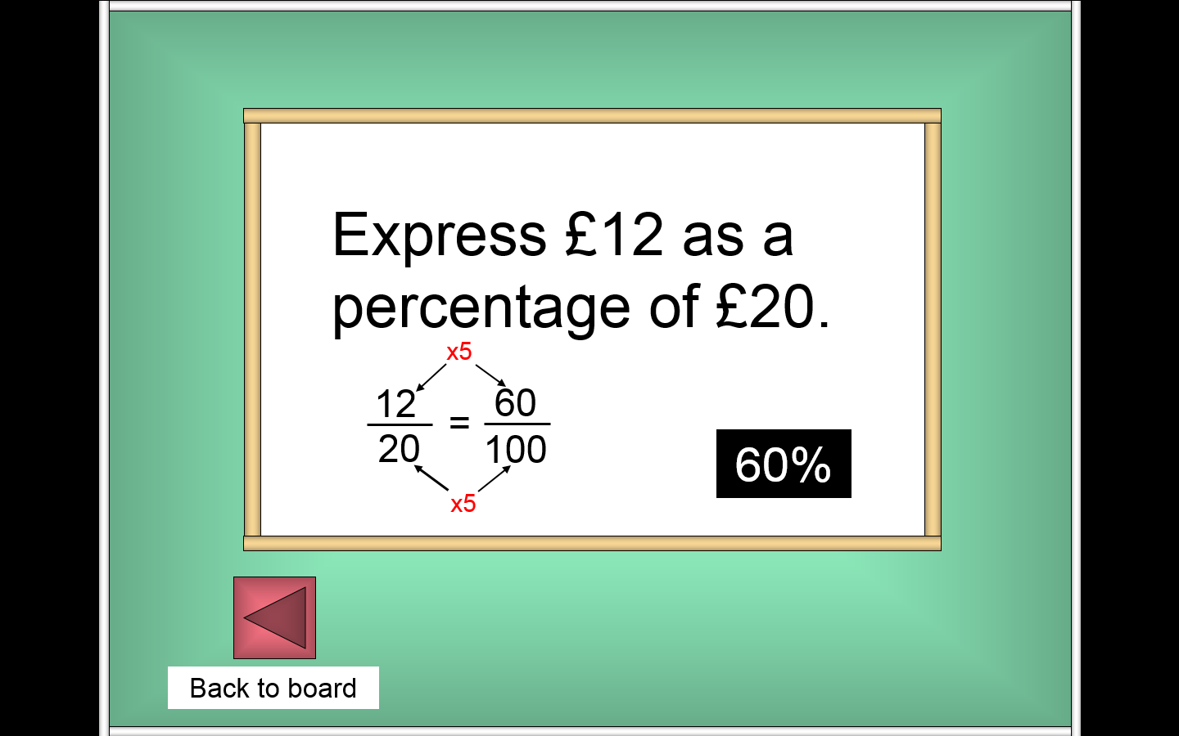

After the topic and grade difficulty of a question is selected, a page appears showing you the question specified. Clicking the reveal button will show you the answer of the question and how to arrive at the answer.